Doitcar-PS2 control car
User manual
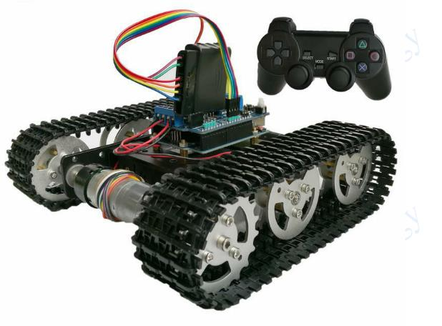
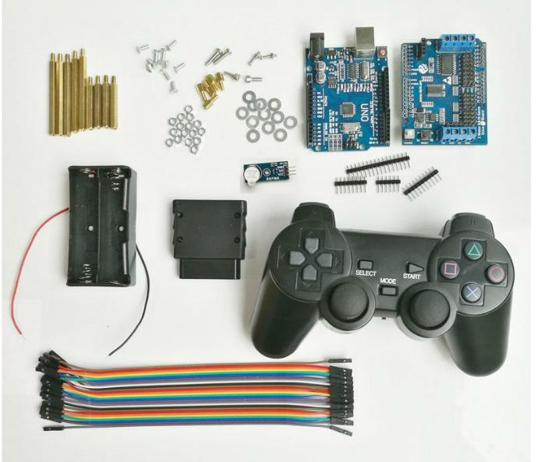
Control kit
1. Product overview
DoitCar_PS2 handle control car is based on Arduino UNO R3
Development board, use the Arduino IDE to develop intelligent tank car, the UNO development board as the main control board, use the driver board which is fully compatible with the UNO "2 road motor & 16 road servo drive board" for car, and for signal transmission, on the development board connected PS2 handle receiving module, with the PS2 controller can realize the function of manual control of the car.
2. Materials Preparation
Materials List:
Name | Quantities
Tank car | 1
Uno development board | 1
Motor driver board | 1
18650 battery box | 1
18650 battery 3.7V | 2
PS2 handle receiver | 1
PS2 handle controller | 1
Active buzzer | 1
Dupont line(F-F) | 6
Single pass 3mm support coupling | 1
M3 nut | 1
M3*6 flat head screws | 1

Item Pictures:
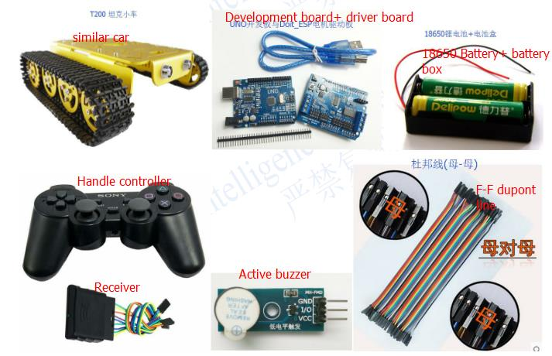
2. Installation and the wiring
Installation
- As the picture 1, insert the pin header to the front of the driver board, weld firmly on the back, the effect as the picture 2 showed:
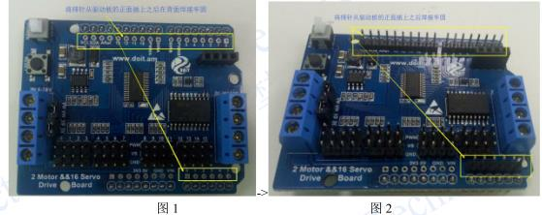
- Install 4pcs single pass 6mm support coupling into the UNO development board, and try to find 2 circle holes, use M3 nut to lock the UNO development board to make it fixed in the tank chassis; install the support coupling into the active buzzer, fix it in the car chassis(lock it and fix it with M3 nut)

Wiring
- At first, insert the motor wires to the wiring slot on the motor encoder, the red and black wires in the every motor wires is the guide line to control the motor; according to the below pictures:(Note: Every motor power supply“+/-”insert to the idle“VS”pin and“GND”pin on the 0～15 road servo pins.

Doit-ESP motor driver board | Power supply/motor/sensor
Wiring end VM | Power supply“+”
Wiring end GND | Power supply“-”
Wiring end A+ | Left motor“red wire”
Wiring end A- | Left motor“black wire”
Wiring end B+ | Right motor“red wire”
Wiring end B- | Right motor“black wire”
Pin 3 | Buzzer I/O
Pin 2 | Cthode of the Led light(short pin) connection in parallel

Doit-ESP motor driver board | PS2 handle receiver
Pin 13 | DI/DAT
Pin 12 | CLK
Pin 11 | DO/CMD
Pin 10 | CS/SEL
Pin 5V(VS) | VDD
Pin GND | GND
- Items connection picture:
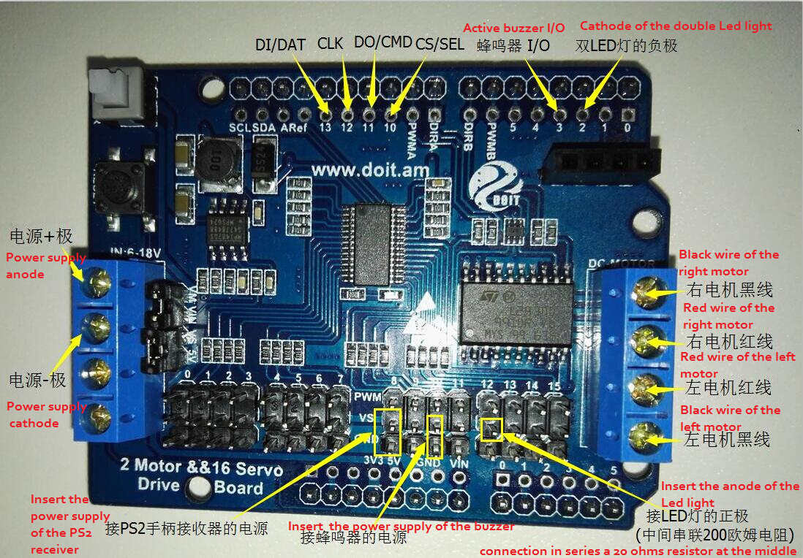
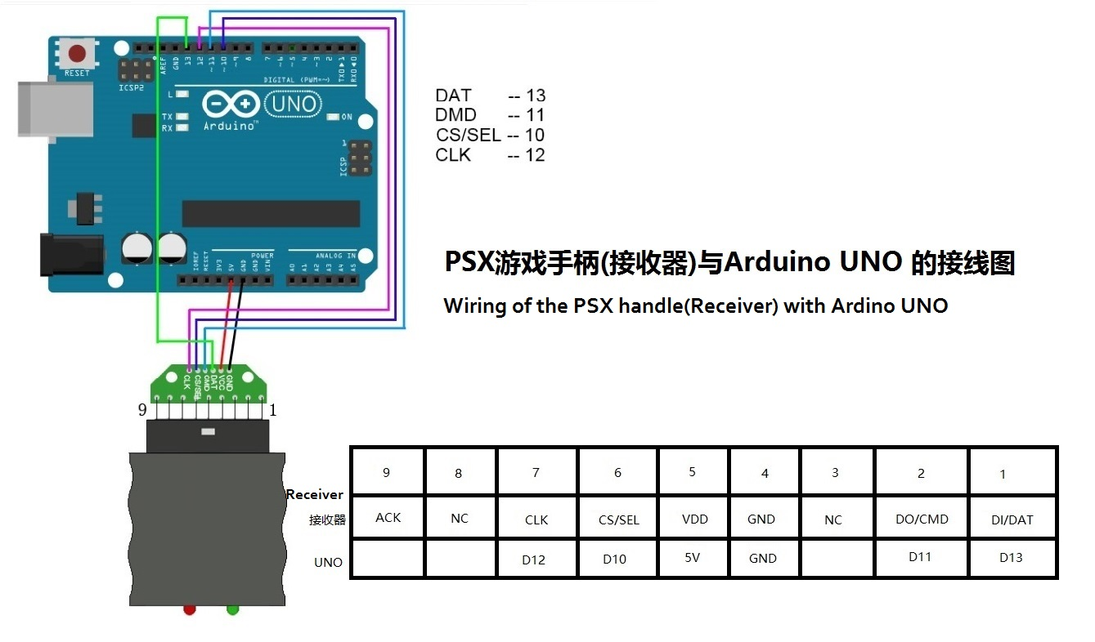
- The effect of the car after installation:
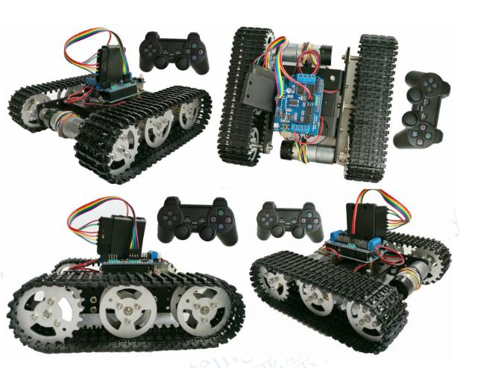
3. Function and principle
Function introduction:
Manual mode of PS2 handle control:
The DoitCar_PS2 car can control the forward, backward, left and right of the car through the PS2 handle, and control the on or off of the LED lights in the car and the chirping of the buzzer (if the package includes);
Principle introduction:
Insert the Doit-ESP motor driver board on the UNO development board, ue the inverter on the drive board, y ou only need 4 IO ports to control the left and right motor.
PS2 handle insert to the 10～13 pins on the drive board, correspondance to the D10～D13 pin on the UNO board, it is hardware SPI of the UNO board, so this handle reciver is based on the SPI protocol with UNO board to communicate.
4. Operating instruction
1)Open the power switch of the Doit-Driver board, you can observe that the led light of the handle reciver which connect with the driver board is in a flashing status, put the handle switch dia to“on”, wait some minutes, the led light on the receiver will be brighted.
2)Press the 4 button on the left of the handle, can control the forward, backward, left and right of the car, press the“select”to stop moving.
3) Hold the right rocker on your right hand, shake the left rocker to control the car.
4)Press the“△”or“×”can manually control the car led light and the chirping of the buzzer.
5. Note
1)If you can’t control the car normally, please check whether the motor wiring of the car is right or not, whether the Short circuit block is insert on the driver boad or not;
2)Because the car chassis is metal materials, in order to avoid shorting circuit, please use the short couplings to isolate between the car plate and the control board.

